Impressions of Uday
I had the opportunity to meet P.Ganesham Sir at an event, in our interaction he advised me to join him in Chinna Shodha Yatra (CSY). I participated in CSY for the first time with limited expectations as I had no idea how it gonna be. On day 1, of the 3-day yatra, we had an orientation program that gave me a glimpse of my co-yatri's. We started our yatra as a group of individuals and by the end of day 1 some magic happened and it was like a family excursion.

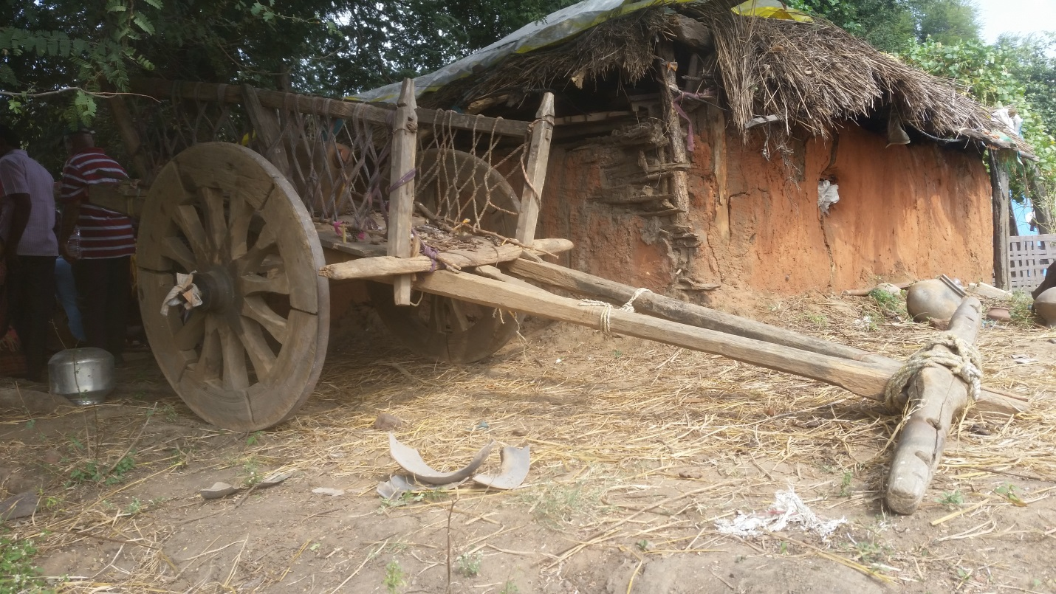A typical Farmer's house in Village

On this occasion I got a chance to interact with the people from villages all along the walk, they were so humble, sincere and optimistic. They were busy but always open-heartedly interacted with us. I was astonished by the lush green landscapes and undeterred atmosphere. Walking with people with different mindsets widens our ability to think and learn many new aspects. The co-yatri's were very patient and helpful in some or the other way. No one judged me or others but provided constructive criticism and comments whenever our thoughts clashed. The questionnaire during walk tried our ability to think, process and reason. The silent walk allowed me to listen to the chitchat of creatures of the night and the silence opened up my thought process. Throughout the walk, the senior yatri's inspired others with amazing anecdotes.

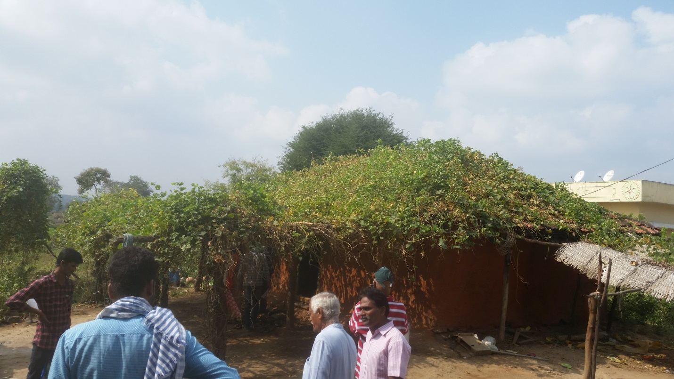
Interaction with a farmer and the house with green vegetable creeper

I strongly believe that participation in CSY would not only improve lifestyle but also their physical and mental abilities. I have to accept the fact that villages are an incredible source of knowledge and energy. I have gained new family members and made wonderful memories. I thank Raju anna and the volunteers for taking care. I would like to thank for the opportunity to participate and certainly be indebted to PalleSrujana for organizing an event like CSY.

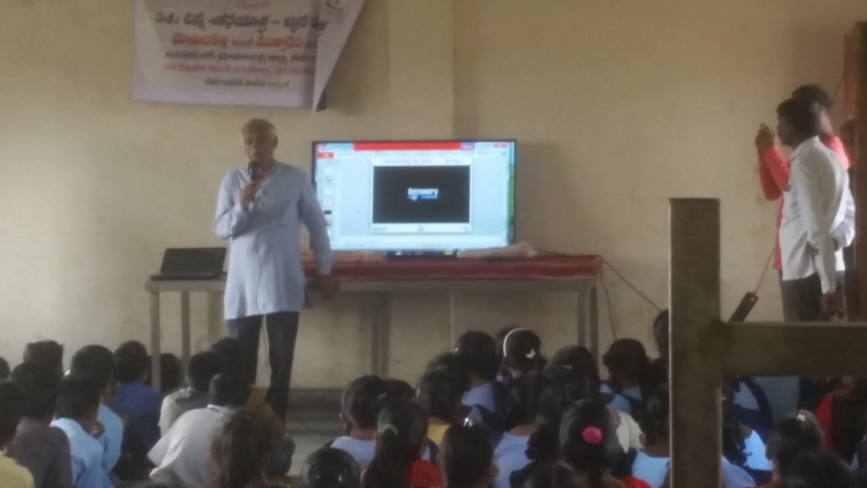
Interacting with school students at Village Golla Budhharam

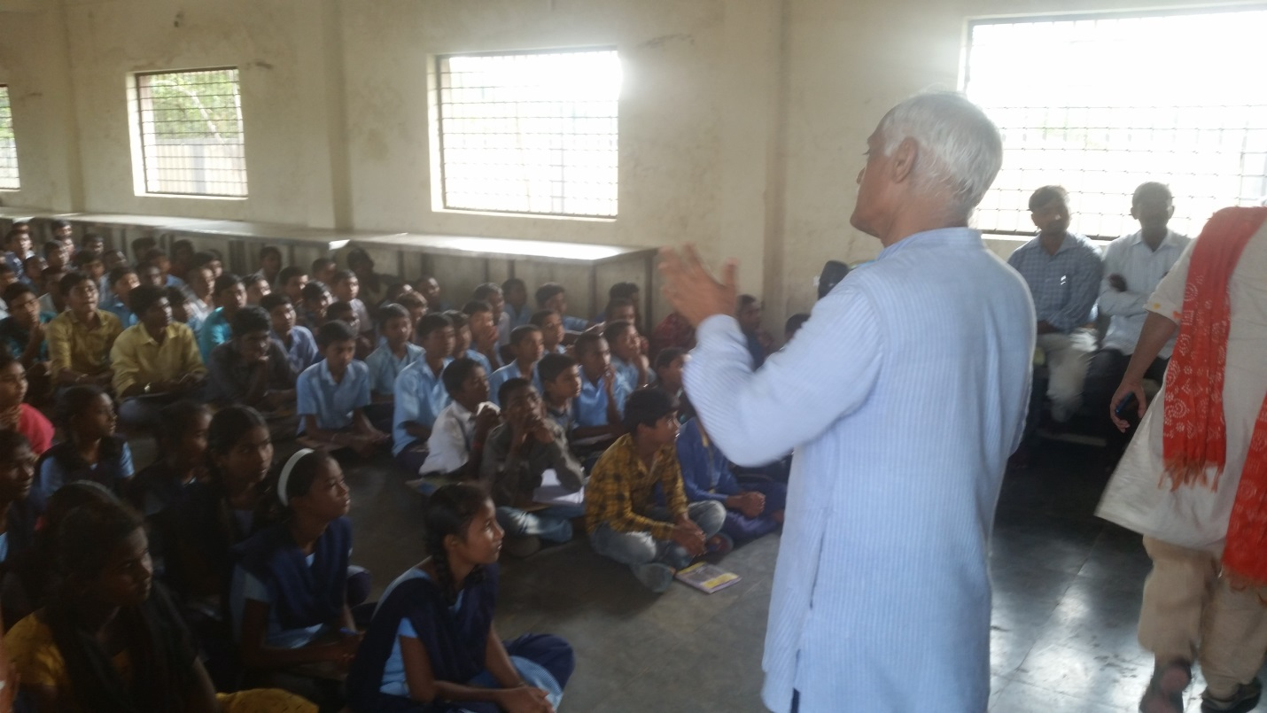
Interaction with school students at Golla Budhharam

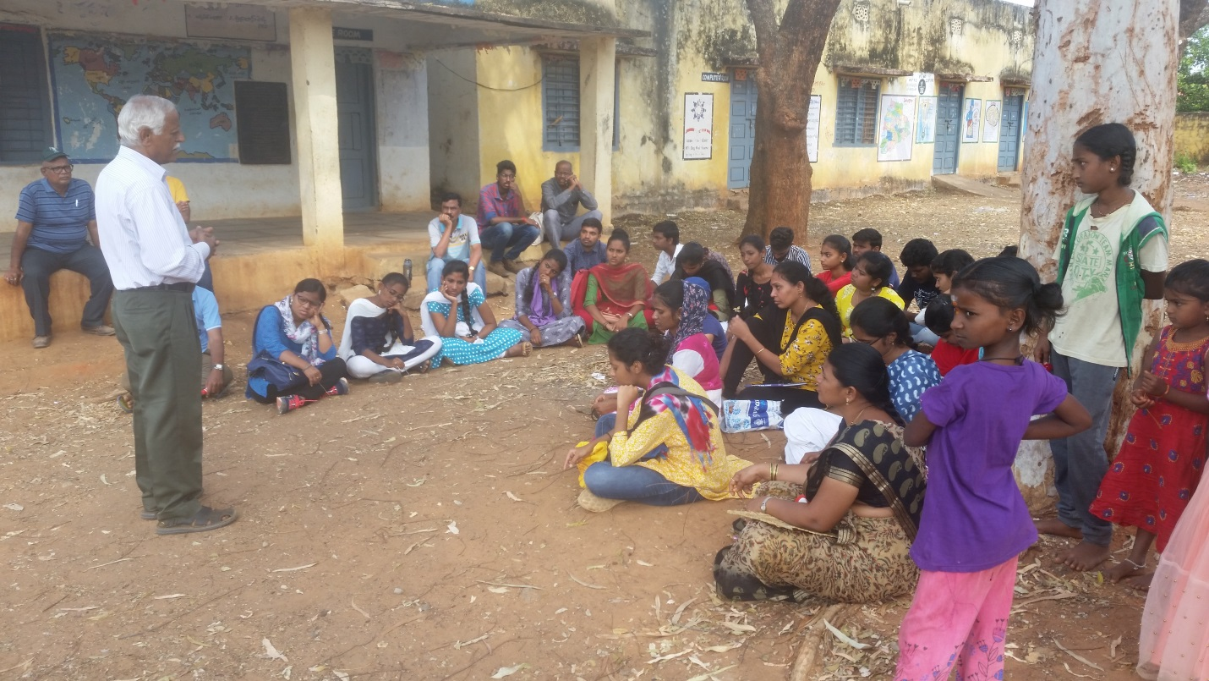
Sharing stories of Innovators on third day

Yours truly,
Uday Kumar Setty

